Project Title | Password Strength Evaluator and Enhancer Using Greedy Algorithms
Student Name | Harshil Patel
Enrolment Numbers | 12202040501026

Project Description
This project involves developing a C program that evaluates the strength of user provided passwords and suggests improvements to enhance their security using a greedy approach. The program assesses passwords based on several criteria, including length, character types (lowercase, uppercase, digits, special characters), and common patterns or dictionary words.
Key Features:
- Password Strength Calculation: The program calculates the strength of a password by evaluating its length, character diversity, and common vulnerabilities. It provides a percentage score reflecting the overall strength of the password.
- Character Type Check: It checks if the password includes all necessary character types—lowercase letters, uppercase letters, digits, and special characters.
- Dictionary Word Detection: The program detects and flags the use of common dictionary words, which can weaken password security.
- Pattern Breaking: It identifies and alters common patterns and sequences within the password to improve its robustness.
- Greedy Improvements: The program applies greedy modifications to the password, such as adding missing character types and breaking common patterns, while ensuring it does not exceed the maximum length.
- User Interaction: Users can choose to keep the improved password or re-enter a new one. The program provides options to display password statistics, generate strong password suggestions, or exit.
Functionality:
- Input Handling: The user inputs a password, and the program calculates its strength and provides feedback.
- Strength Metrics: The program assesses the password’s length and diversity, penalizes common patterns, and evaluates the overall security score.
- Suggestions and Enhancements: If the password is deemed weak, the program provides specific suggestions for improvement and offers to make greedy enhancements.
- Menu Interface: A simple menu interface allows users to view password statistics, generate strong password suggestions, or exit the program.
Implementation Details:
- Data Handling: The program uses standard C libraries for string manipulation, character checking, and random number generation.
- User Interaction: Input is handled via the command line, with clear prompts and instructions to guide the user through the process.
This project demonstrates an application of greedy algorithms in a practical context, enhancing password security through iterative improvements and user interaction.

Source Code
#include <stdio.h>
#include <string.h>
#include <ctype.h>
#include <stdlib.h>
#include <time.h>

#define MIN_LENGTH 8
#define MAX_LENGTH 20

// Global variables
int hasLower = 0;
int hasUpper = 0;
int hasDigit = 0;
int hasSpecial = 0;

// Function prototypes
int isDigit(char c);
int isSpecial(char c);
void countCharTypes(const char *password);
int containsDictionaryWord(const char *password);
void breakSequences(char *password);
void addMissingCharacterTypes(char *password, int *len);
int makeGreedyImprovements(char *password);
int calculateStrengthPercentage(const char *password);
int provideWeakPasswordSuggestions(char *password);
void generateStrongPasswordSuggestion(int length);
void displayPasswordStatistics(const char *password);
void displayMenu();

// Check if a charcter is a Digit
int isDigit(char c)
{
return (c >= '0' && c <= '9');
}

// Check is a character is a special character
int isSpecial(char c)
{
return (strchr("!@#$%^&*()-+[]{}|;:,.<>?/", c) != NULL);
}

// Count types of character in password
void countCharTypes(const char *password)
{
hasDigit = hasLower = hasSpecial = hasUpper = 0;
while (*password)
{
if (islower(*password))
hasLower = 1;
if (isupper(*password))
hasUpper = 1;
if (isDigit(*password))
hasDigit = 1;
if (isSpecial(*password))
hasSpecial = 1;
password++;
}
}

// Check if a password contains any common dictionary words
int containsDictionaryWord(const char *password)
{
const char *commonWords[] = {"password", "123456", "qwerty", "abc123", "letmein", "welcome", "admin", "password1"};
int i;
for (i = 0; i < sizeof(commonWords) / sizeof(commonWords[0]); i++)
{
if (strstr(password, commonWords[i]) != NULL)
{
return 1;
}
}
return 0;
}

// Break sequence of repeated characters
void breakSequences(char *password)
{
int len = strlen(password), i;
for (i = 2; i < len; i++)
{
if (password[i] == password[i - 1] && password[i] == password[i - 2])
{
if (password[i] == 'z')
password[i] = 'a';
else if (password[i] == 'Z')
password[i] = 'A';
else
password[i]++;
}
}
}

// Make Greedy Improvements in the password
int makeGreedyImprovements(char *password)
{
countCharTypes(password);

int len = strlen(password);
if (len >= MAX_LENGTH - 4)
return -1;

// Add missing character types if needed
if (!hasLower && len < MAX_LENGTH - 1)
password[len++] = 'a';
if (!hasUpper && len < MAX_LENGTH - 1)
password[len++] = 'A';
if (!hasDigit && len < MAX_LENGTH - 1)
password[len++] = '1';
if (!hasSpecial && len < MAX_LENGTH - 1)
password[len++] = '!';
password[len] = '\0';

// Break common patterns
const char *patterns[] = {"123", "abc", "qwerty"};
int i, j;
for (i = 0; i < sizeof(patterns) / sizeof(patterns[0]); i++)
{
char *pos = strstr(password, patterns[i]);
while (pos)
{
for (j = 0; j < strlen(patterns[i]); j++)
{
if (pos[j] == 'z')
pos[j] = 'a';
else if (pos[j] == 'Z')
pos[j] = 'A';
else
pos[j]++;
}
pos = strstr(pos, patterns[i]);
}
}

// Break sequences introduced by greedy improvements
breakSequences(password);
printf("\n====================================================");
printf("\nPassword after making greedy changes: %s\n", password);
printf("====================================================");

char response[10];
printf("\nDo you want to keep this password? (yes/no): ");
scanf("%9s", response);
printf("====================================================");

if (strcasecmp(response, "yes") == 0)
return 1;
else
return 0;
}

// Calculate the strength of the password
int calculateStrengthPercentage(const char *password)
{
int length = strlen(password);
int lengthScore = 0;
int typeScore = 0;
int penaltyScore = 0;

if (length < MIN_LENGTH || length > MAX_LENGTH)
return -1;

countCharTypes(password);

if (length >= MAX_LENGTH)
lengthScore = 30;
else if (length >= 16)
lengthScore = 25;
else if (length >= 12)
lengthScore = 20;
else if (length >= MIN_LENGTH)
lengthScore = 10;

typeScore += (hasLower ? 10 : 0);
typeScore += (hasUpper ? 10 : 0);
typeScore += (hasDigit ? 15 : 0);
typeScore += (hasSpecial ? 15 : 0);

if (hasLower && hasUpper && hasDigit && hasSpecial)
typeScore += 15;

if (containsDictionaryWord(password))
penaltyScore += 30;

char *tempPassword = strdup(password);
if (tempPassword == NULL)
{
printf("Memory allocation failed.\n");
return -1;
}

breakSequences(tempPassword);
free(tempPassword);

if (strstr(password, "123") || strstr(password, "abc") || strstr(password, "qwerty"))
penaltyScore += 20;

int totalScore = lengthScore + typeScore - penaltyScore;
if (totalScore < 0)
totalScore = 0;
if (totalScore > 100)
totalScore = 100;

return totalScore;
}

// Provide suggestions to improve weak password
int provideWeakPasswordSuggestions(char *password)
{
printf("\n\n=========== Suggestions to strengthen your password =========== \n");
countCharTypes(password);
if (strlen(password) < MIN_LENGTH)
printf("- Increase length to at least %d characters.\n", MIN_LENGTH);
if (!hasLower)
printf("- Add lowercase letters.\n");
if (!hasUpper)
printf("- Add uppercase letters.\n");
if (!hasDigit)
printf("- Add digits.\n");
if (!hasSpecial)
printf("- Add special characters (e.g., !@#$%^&*).\n");
if (containsDictionaryWord(password))
printf("- Avoid using common dictionary words.\n");
if (strstr(password, "123") || strstr(password, "abc") || strstr(password, "qwerty"))
printf("- Avoid common patterns like '123', 'abc', or 'qwerty'.\n");
printf("=============================================================== \n");

int res = makeGreedyImprovements(password);
return res;
}

// Generate a strong password suggestion
void generateStrongPasswordSuggestion(int length)
{
if (length < MIN_LENGTH || length > MAX_LENGTH)
{
printf("Length must be between %d and %d characters.\n", MIN_LENGTH, MAX_LENGTH);
return;
}
char password[length + 1];
const char lower[] = "abcdefghijklmnopqrstuvwxyz";
const char upper[] = "ABCDEFGHIJKLMNOPQRSTUVWXYZ";
const char digits[] = "0123456789";
const char specials[] = "!@#$%^&*()-+[]{}|;:,.<>?/";
static int seeded = 0;
if (!seeded)
{
srand(time(NULL));
seeded = 1;
}

password[0] = lower[rand() % (sizeof(lower) - 1)];
password[1] = upper[rand() % (sizeof(upper) - 1)];
password[2] = digits[rand() % (sizeof(digits) - 1)];
password[3] = specials[rand() % (sizeof(specials) - 1)];
int i;
for (i = 4; i < length; i++)
{
int type = rand() % 4;
switch (type)
{
case 0:
password[i] = lower[rand() % (sizeof(lower) - 1)];
break;
case 1:
password[i] = upper[rand() % (sizeof(upper) - 1)];
break;
case 2:
password[i] = digits[rand() % (sizeof(digits) - 1)];
break;
case 3:
password[i] = specials[rand() % (sizeof(specials) - 1)];
break;
}
}
password[length] = '\0';
printf("\n===================================================================\n");
printf("Example of a strong password with length %d: %s\n", length, password);
printf("===================================================================\n");
}

// Display password statistics
void displayPasswordStatistics(const char *password)
{
countCharTypes(password);

int length = strlen(password);
printf("\n===== Password Statistics ======\n");
printf("Length: %d\n", length);
printf("Contains lowercase letters: %s\n", hasLower ? "Yes" : "No");
printf("Contains uppercase letters: %s\n", hasUpper ? "Yes" : "No");
printf("Contains digits: %s\n", hasDigit ? "Yes" : "No");
printf("Contains special characters: %s\n", hasSpecial ? "Yes" : "No");
printf("\n================================\n");
}

// Display the menu for user options
void displayMenu()
{
printf("\n\n============== Menu =============\n");
printf("1. Display password statistics\n");
printf("2. Generate a password suggestion\n");
printf("3. Exit\n");
printf("=================================\n");
printf("Enter your choice: ");
}

int main()
{

printf("\n*---------------------------------- MINI PROJECT ----------------------------------*");
printf("\nSUBJECT NAME: DESIGN AND ANALYSIS OF ALGORITHMS");
printf("\nSUBJECT CODE: 202045601");
printf("\nMINI PROJECT TITLE: PASSWORD STRENGHT EVALUATER AND ENHANCER USING GREEDY ALGORITHMS");
printf("\n\nDeveloped by: HARSHIL PATEL <12202040501026>");
printf("\n KRUSHIL DOBARIYA <12202040501036>");
printf("\n*----------------------------------------------------------------------------------*\n\n");

char password[100];
int strengthPercentage;
int validPassword = 0;
int choice, res;
label:
printf("\nEnter password(or enter 'exit' to quit): ");
scanf("%99s", password);

if (strcmp(password, "exit") == 0)
{
printf("\n\nExiting.......");
return 0;
}
else
{
strengthPercentage = calculateStrengthPercentage(password);

if (strengthPercentage == -1)
{
printf("Password length must be between %d and %d characters. Please try again.\n", MIN_LENGTH, MAX_LENGTH);
}
else
{
if (strengthPercentage >= 75)
{
printf("\nPassword is strong \n");
do
{
label1:
displayMenu();
scanf("%d", &choice);
switch (choice)
{
case 1:
displayPasswordStatistics(password);
break;
case 2:
generateStrongPasswordSuggestion(strlen(password));
break;
case 3:
printf("Exiting...\n");
return 0;
default:
printf("Invalid choice. Please enter a number between 1 and 3.\n");
break;
}
} while (choice != 3);
}

else
{
printf("\nPassword is weak.\n");
res = provideWeakPasswordSuggestions(password);
if (res == -1)
{
printf("\nInsufficient space for adding new charcters");
}
if (res == 0)
goto label;
if (res == 1)
goto label1;
}
}
}

return 0;
}

Example 1: Password Strength Evaluation
User Input:
The user enters the password: 'Pass@word859'

Step by Step Execution:
1. Initial Check:
The password 'Pass@word859' has a length of 12 characters, which is within the acceptable range of 8 to 20 characters. The algorithm proceeds to evaluate the password strength.
2. Calculate Strength Percentage:
Length Score Calculation:
- Length = 12 characters.
- Length score = 20 (since length is between 12 and 16).
Character Type Check:
- Contains lowercase letters: Yes ('assword')
- Contains uppercase letters: Yes ('P')
- Contains digits: Yes ('859')
- Contains special characters: Yes ('@')
- Type score = 10 (lowercase) + 10 (uppercase) + 15 (digits) + 15 (special) + 15 (all types present) = 65.
Penalty Check:
- Contains common patterns: No.
- No dictionary words.
Total Score Calculation:
- Total Score = Length Score + Type Score Penalty Score = 20 + 65 0 = 85.

3. Final Output:
The strength percentage of 'Pass@word859' is 85. Since it is greater than 75, the password is classified as strong.

Menu Options:
The user is prompted to display password statistics or generate a strong password suggestion.

Example 2: Password Enhancement
User Input:
The user enters the password: 'harshil123'

Step by Step Execution:
1. Initial Check:
The password 'harshil123' has a length of 10 characters, which is within the acceptable range of 8 to 20 characters. The algorithm proceeds to evaluate the password strength.

2. Calculate Strength Percentage:
Length Score Calculation:
- Length = 10 characters.
- Length score = 10 (since length is between 8 and 12).
Character Type Check:
- Contains lowercase letters: Yes ('harshil')
- Contains uppercase letters: No.
- Contains digits: Yes ('123')
- Contains special characters: No.
- Type score = 10 (lowercase) + 15 (digits) = 25.
Penalty Check:
- Contains common patterns: Yes ('123' is a common pattern).
- No dictionary words.
Total Score Calculation:
- Total Score = Length Score + Type Score Penalty Score = 10 + 25 - 20 = 15.

3. Final Output:
The strength percentage of 'harshil123' is 15. Since it is less than 75, the password is classified as weak.
Suggestions for Improvement:
- Add uppercase letters.
- Add special characters.
- Increase length to at least 8 characters.
- Avoid common patterns like '123'.
4. Greedy Improvements:
The program makes greedy improvements:
- Add missing character types: Add 'A' (uppercase), '!' (special).
- Resulting password: 'harshil123A!'.
User Decision:
- The user is asked if they want to keep the improved password.
- If the user agrees, they can proceed with the improved password.
- If not, they can enter a new password to repeat the process.

Output
Case 1: input is Pass@word859
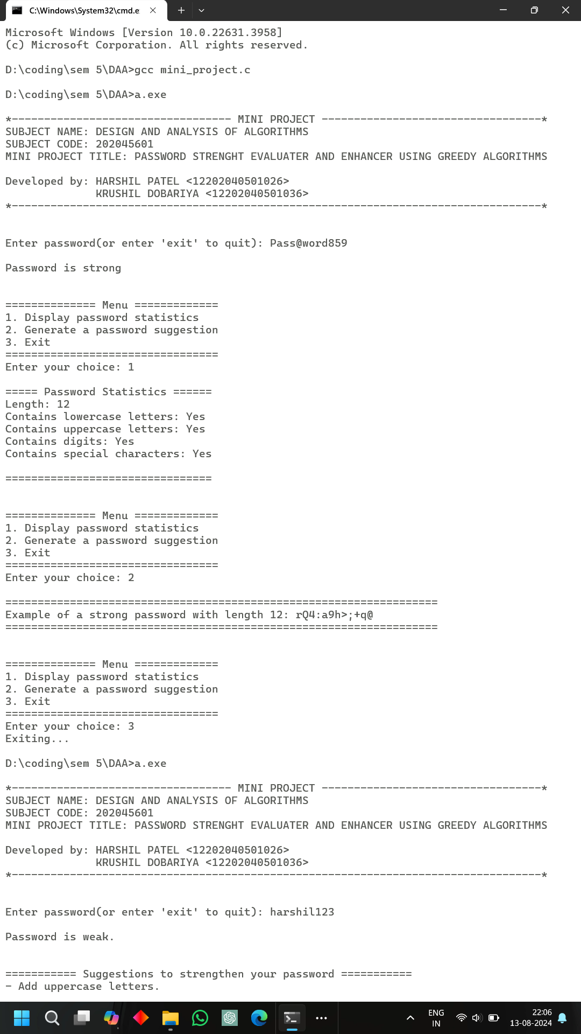
Case 2: input is harshil123
